**Arbor Woods**

**Piedmont, SC**

**Incredible Value**

Plenty to offer for the perfect price!!

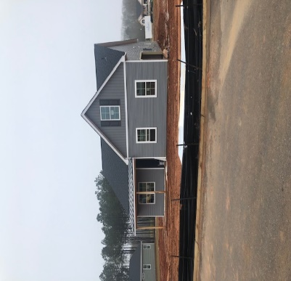

# Westin D

# 500 Coppice Court| 3 Bedrooms | 2.5 Bathrooms | 1,936 Square Footage

# Including bonus!

# $259,018

**See agent for current incentives!**

**\*No closing costs including credit report, appraisal & pre-paids up to $2,500. Seller/Lender will pay all buyers required closing costs (excluding optional owners title) and up to $2500 in pre-paids which are defined as required escrow items - hazard insurance, flood (only if property is located in flood zone that requires insurance) and taxes. Note: HOA dues are not escrow items. Offer subject to use of Seller's preferred lender and closing attorney and contracts written June - June 30, 2017. Offer subject to change at any time without notice. Incentives vary per community and a minimum amount of options may be required to qualify for the half off options promotion, please see agent for details. To be eligible to receive the washer/dryer, fridge or blinds promotion customers must comply with incentives per community, restrictions may apply.Windermere**

* Just 20 minutes from shopping, dinning, and entertainment
* Clean white colors, with durable laminate wood flooring
* Side entry garage
* Spacious corner .48 acre lot
* Screen Porch

**CALL OUR AGENT TODAY OR VISIT OUR BRAND NEW DECORATED MODEL HOME!**

**Reagan Sanders | 864.631.9530** [**reagan.sanders@crescenthomes.net**](mailto:reagan.sanders@crescenthomes.net)  
**Model Address:** 2 Arbor Woods Lane, Piedmont SC 29673  
[www.crescenthomes.net](http://www.crescenthomes.net/)