Waterloo Estates
Johns Island, South Carolina

CALL 843-872-6447 ABOUT HOME

Waterloo is Johns Islands Newest Gated Community Featuring half acre and larger lots, serene oak trees, lots of woods and wetland conservation.

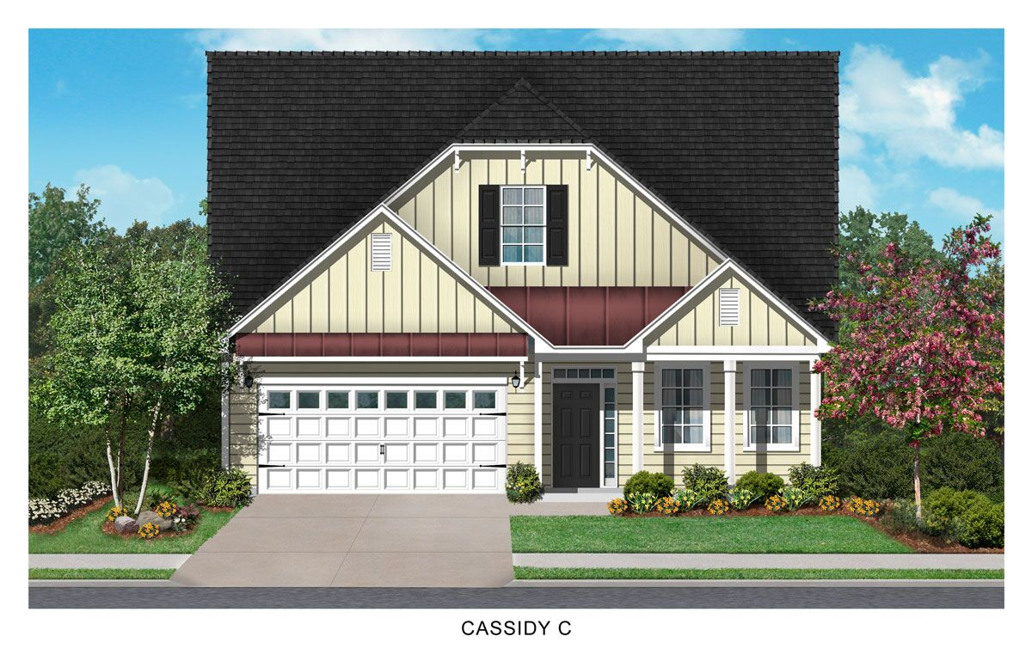

CALL OUR AGENT TODAY OR VISIT OUR BRAND NEW DECORATED MODEL HOME!
Keith Twillman | 843-297-0661 Keith.Twillman@CrescentHomes.net
or John Burnett | 843-834-6056 John.Burnett@CrescentHomes.net
Model Address: 2828 Olivia Marie Lane, Johns Island, SC 29455
www.crescenthomes.net

Cassidy C

3264 Olivia Marie Lane | 4 Bedrooms | 2.5 Bathrooms | Sq. Ft. 2649 Lot 55

$516,158

No Closing Costs, No Really! Plus, up to $2,500 in pre-paids.
Home Town Hero Incentive (qualified buyers)

*No closing costs including credit report, appraisal & pre-paids up to $2,500. Seller/Lender will pay all buyers required closing costs (excluding optional owners title) and up to $2500 in pre-paids which are defined as required escrow items - hazard insurance, flood (only if property is located in flood zone that requires insurance) and taxes. Note: HOA dues are not escrow items. Offer subject to use of Seller's preferred lender and closing attorney and contracts September2018. Offer subject to change at any time without notice. Incentives vary per community and a minimum amount of options may be required to qualify for the half off options promotion, please see agent for details.

